Faculty of Computing

SE-314: Software Construction
Class: BESE 14AB

Lab 10: Abstract Data Type - I

CLO-03: Design and develop solutions based on Software Construction principles.
CLO-04: Use modern tools such as Eclipse, NetBeans etc. for software construction.

Date: 17th Nov 2025
Time: 09:00 AM - 11:50 PM
02:00 PM – 04:50 PM

Submitted By: Sikander Hayat Khan
CMS ID: 464544

Instructor: Dr. Sidra Sultana
Lab Engineer: Mr. Aftab Farooq

Lab 10: ADT

Gtihub Repo Link: https://github.com/Sikander-Hayat-Khan/SC-LAB-10.git

Introduction:
Students will have hands-on experience on designing, testing, and implementing abstract data types. Given a set of specifications, you will write unit tests that check for compliance with the specifications, and then implement code that meets the specifications.
Material:
https://ocw.mit.edu/ans7870/6/6.005/s16/psets/ps2/

Lab Tasks

Solve problem 1-2 of problem set 2 listed on the link. The type we will implement is Graph<L>: an abstract data type for mutable weighted directed graphs with labeled vertices.

Task1:
Devise, document, and implement tests for Graph<String> .
For now, we’ll only test (and then implement) graphs with String vertex labels. Later, we’ll expand to other kinds of labels.
In order to accommodate running our tests on multiple implementations of the Graph
interface, here is the setup:
- The testing strategy and tests for the static Graph.empty() method are in GraphStaticTest.java . Since the method is static, there will be only one implementation, and we only need to run these tests once. We’ve provided these tests. You are free to change or add to them, but you can leave them as-is for this problem.
- Write your testing strategy and your tests for all the instance methods in GraphInstanceTest.java . In these tests, you must use the emptyInstance() method to get fresh empty graphs, not Graph.empty() ! See the provided testInitialVerticesEmpty() for an example.
In Task-01, you test all basic functionalities of the Graph ADT:
- Creating new graph
- Adding vertices
- Preventing duplicates
- Removing vertices
- Adding, updating, and deleting edges
- Checking vertices list
- Checking edge sources and targets
These tests ensure that any implementation of Graph<String> behaves correctly.
Task2:

Implement weighted directed graphs with String labels — twice . Check further details on the link. And provide the following for all the classes in this task:

Document the abstraction function and representation invariant .
- Along with the rep invariant, document how the type prevents rep exposure .
- Implement checkRep to check the rep invariant.
- Implement toString with a useful human-readable representation of the abstract value.
In Task-02
1. add(String vertex):
  - Adds a new vertex to the graph if it isn't already present. Returns true if the vertex was added, false if it already exists.
- set(String source, String target, int weight):
  - Adds or updates a directed edge from source to target with the specified weight. If the weight is zero, it removes the edge; if the edge exists, it updates its weight and returns the previous weight.
- remove(String vertex):
  - Removes a vertex from the graph along with any edges that either start or end at that vertex. Returns true if the vertex was removed, false if it wasn’t found.
- vertices():
  - Returns an unmodifiable set of all vertices in the graph, ensuring the list of vertices cannot be modified directly.
- sources(String target):
  - Returns a map of vertices that have directed edges to the given target vertex. The key is the source vertex, and the value is the weight of the edge.
- targets(String source):
  - Returns a map of vertices that are the targets of edges from the given source vertex. The key is the target vertex, and the value is the weight of the edge.
- toString():
  - Returns a string representation of the graph, including all vertices and edges with their respective weights, in a human-readable format.
- checkRep():
  - Ensures that the internal representation of the graph is valid. Verifies that the vertices set and edges list are non-null and that each edge connects valid vertices.
- getSource():
  - Returns the source vertex of the edge.
- getTarget():
  - Returns the target vertex of the edge.
- getWeight():
  - Returns the weight of the edge.
- toString():
  - Returns a string representation of the edge in the format: "source -> target (weight)".
- Edge(String source, String target, int weight) (Constructor):
  - Initializes an edge with a source vertex, a target vertex, and a non-negative weight. Throws an IllegalArgumentException if the source, target, or weight is invalid (null source or target, or negative weight).

Solution
Task 1:
Test Cases:
@Test(expected=AssertionError.class)
public void testAssertionsEnabled() {
assert false; // make sure assertions are enabled with VM argument: -ea
}
@Test
public void testInitialVerticesEmpty() {
// TODO you may use, change, or remove this test
assertEquals("expected new graph to have no vertices",
Collections.emptySet(), emptyInstance().vertices());
}
// TODO other tests for instance methods of Graph
@Test
public void testAddVertex() {
Graph<String> g = emptyInstance();
assertTrue(g.add("A"));
assertTrue(g.add("B"));
assertEquals(Set.of("A", "B"), g.vertices());
}
@Test
public void testAddDuplicateVertex() {
Graph<String> g = emptyInstance();
assertTrue(g.add("X"));
assertFalse(g.add("X")); // duplicate
assertEquals(Set.of("X"), g.vertices());
}
@Test
public void testRemoveVertexNotInGraph() {
Graph<String> g = emptyInstance();
assertFalse(g.remove("Z"));
}
@Test
public void testRemoveExistingVertexNoEdges() {
Graph<String> g = emptyInstance();
g.add("A");
assertTrue(g.remove("A"));
assertTrue(g.vertices().isEmpty());
}
@Test
public void testRemoveVertexWithEdges() {
Graph<String> g = emptyInstance();
g.set("A", "B", 5);
g.set("C", "A", 2);
assertTrue(g.remove("A"));
assertEquals(Set.of("B", "C"), g.vertices());
assertTrue(g.sources("B").isEmpty());
assertTrue(g.targets("C").isEmpty());
}
@Test
public void testSetAddNewEdge() {
Graph<String> g = emptyInstance();
int previous = g.set("A", "B", 10);
assertEquals(0, previous);
assertEquals(Set.of("A", "B"), g.vertices());
assertEquals(Map.of("A", 10), g.sources("B"));
assertEquals(Map.of("B", 10), g.targets("A"));
}
@Test
public void testSetUpdateExistingEdge() {
Graph<String> g = emptyInstance();
g.set("A", "B", 5);
int previous = g.set("A", "B", 9);
assertEquals(5, previous);
assertEquals(Map.of("B", 9), g.targets("A"));
}
@Test
public void testSetRemoveExistingEdge() {
Graph<String> g = emptyInstance();
g.set("A", "B", 4);
int previous = g.set("A", "B", 0);
assertEquals(4, previous);
assertTrue(g.targets("A").isEmpty());
}
@Test
public void testSetRemoveNonExistingEdge() {
Graph<String> g = emptyInstance();
int previous = g.set("X", "Y", 0);
assertEquals(0, previous);
}
@Test
public void testVerticesAfterAddAndRemove() {
Graph<String> g = emptyInstance();
g.add("A");
g.add("B");
g.add("C");
g.remove("B");
assertEquals(Set.of("A", "C"), g.vertices());
}
@Test
public void testSourcesMultiple() {
Graph<String> g = emptyInstance();
g.set("A", "C", 1);
g.set("B", "C", 2);
assertEquals(Map.of("A", 1, "B", 2), g.sources("C"));
}
@Test
public void testTargetsMultiple() {
Graph<String> g = emptyInstance();
g.set("A", "X", 3);
g.set("A", "Y", 4);
assertEquals(Map.of("X", 3, "Y", 4), g.targets("A"));
}
@Test
public void testNoSourcesOrTargetsForIsolatedVertex() {
Graph<String> g = emptyInstance();
g.add("A");
assertTrue(g.sources("A").isEmpty());
assertTrue(g.targets("A").isEmpty());
}

Output:
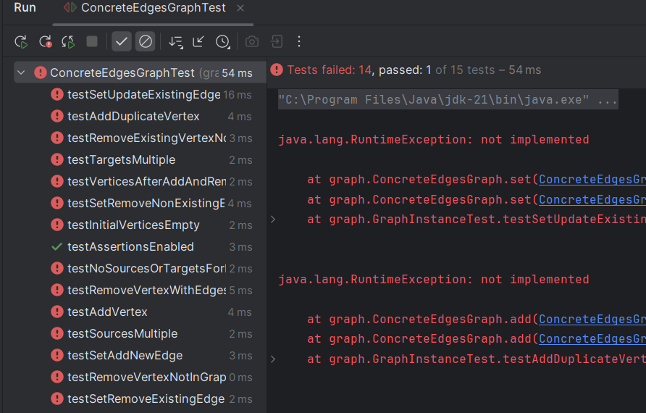

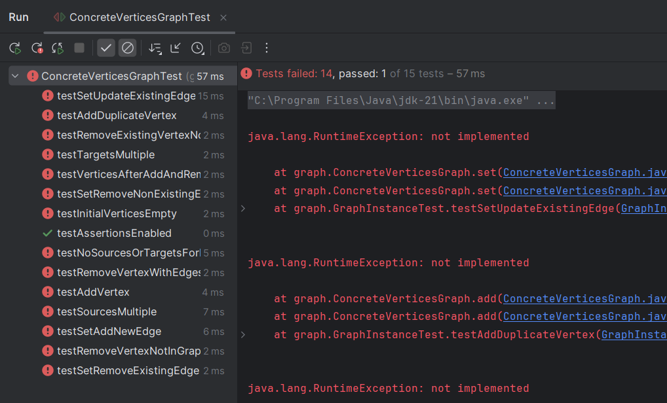

Task 2:
ConcreteEdgesGraph.java:
public class ConcreteEdgesGraph implements Graph<String> {
private final Set<String> vertices = new HashSet<>();
private final List<Edge> edges = new ArrayList<>();
// Abstraction function:
// AF(c) = A weighted directed graph with vertices "vertices"
// and edges as listed in "edges".
//
// Representation invariant:
// vertices != null
// edges != null
// every edge's source and target exist in vertices
// all edge weights >= 0
//
// Safety from rep exposure:
// vertices() returns unmodifiable set
// edges are immutable (Edge is immutable)
// sources() and targets() return new Maps each time
public ConcreteEdgesGraph() {
checkRep();
}
private void checkRep() {
for (Edge e : edges) {
assert vertices.contains(e.getSource()) : "edge source not in vertices";
assert vertices.contains(e.getTarget()) : "edge target not in vertices";
assert e.getWeight() >= 0 : "edge weight negative";
}
}
@Override
public boolean add(String vertex) {
Objects.requireNonNull(vertex);
boolean added = vertices.add(vertex);
checkRep();
return added;
}
@Override
public int set(String source, String target, int weight) {
Objects.requireNonNull(source);
Objects.requireNonNull(target);
if (weight < 0) throw new IllegalArgumentException("weight < 0");
vertices.add(source);
vertices.add(target);
int oldWeight = 0;
Iterator<Edge> it = edges.iterator();
while (it.hasNext()) {
Edge e = it.next();
if (e.getSource().equals(source) && e.getTarget().equals(target)) {
oldWeight = e.getWeight();
if (weight == 0) {
it.remove();
} else {
it.remove();
edges.add(new Edge(source, target, weight));
}
checkRep();
return oldWeight;
}
}
if (weight > 0) {
edges.add(new Edge(source, target, weight));
}
checkRep();
return oldWeight;
}
@Override
public boolean remove(String vertex) {
Objects.requireNonNull(vertex);
boolean removed = vertices.remove(vertex);
if (removed) {
edges.removeIf(e -> e.getSource().equals(vertex) || e.getTarget().equals(vertex));
}
checkRep();
return removed;
}
@Override
public Set<String> vertices() {
return Collections.unmodifiableSet(new HashSet<>(vertices));
}
@Override
public Map<String, Integer> sources(String target) {
Objects.requireNonNull(target);
Map<String, Integer> result = new HashMap<>();
for (Edge e : edges) {
if (e.getTarget().equals(target)) {
result.put(e.getSource(), e.getWeight());
}
}
return result;
}
@Override
public Map<String, Integer> targets(String source) {
Objects.requireNonNull(source);
Map<String, Integer> result = new HashMap<>();
for (Edge e : edges) {
if (e.getSource().equals(source)) {
result.put(e.getTarget(), e.getWeight());
}
}
return result;
}
@Override
public String toString() {
StringBuilder sb = new StringBuilder();
sb.append("Vertices: ").append(vertices).append("\nEdges:\n");
for (Edge e : edges) {
sb.append(" ").append(e.toString()).append("\n");
}
return sb.toString();
}
/** Immutable edge class for ConcreteEdgesGraph */
static class Edge {
private final String source;
private final String target;
private final int weight;
// Abstraction function:
// AF(e) = a directed edge from source to target with weight
// Representation invariant:
// - source != null
// - target != null
// - weight >= 0
// Safety from rep exposure:
// - all fields are private final, immutable
public Edge(String source, String target, int weight) {
Objects.requireNonNull(source);
Objects.requireNonNull(target);
if (weight < 0) throw new IllegalArgumentException("weight < 0");
this.source = source;
this.target = target;
this.weight = weight;
checkRep();
}
private void checkRep() {
assert source != null;
assert target != null;
assert weight >= 0;
}
public String getSource() { return source; }
public String getTarget() { return target; }
public int getWeight() { return weight; }
@Override
public String toString() {
return source + " -> " + target + " (" + weight + ")";
}
}
}

ConcreteVerticesGraph.java:
public class ConcreteVerticesGraph implements Graph<String> {
private final List<Vertex> vertices = new ArrayList<>();
// Abstraction function:
// AF(c) = weighted directed graph with vertices in the list
// Representation invariant:
// - vertices != null
// - each Vertex != null
// - vertex names are unique
// - all target weights >= 0
// Safety from rep exposure:
// - returns copies or unmodifiable sets/maps
// - Vertex class encapsulates mutable targets
public ConcreteVerticesGraph() {
checkRep();
}
private void checkRep() {
assert vertices != null;
Set<String> names = new HashSet<>();
for (Vertex v : vertices) {
assert v != null;
assert !names.contains(v.getName());
names.add(v.getName());
for (int w : v.getTargets().values()) {
assert w >= 0;
}
}
}
private Vertex findVertex(String name) {
for (Vertex v : vertices) {
if (v.getName().equals(name)) return v;
}
return null;
}
@Override
public boolean add(String vertex) {
Objects.requireNonNull(vertex);
if (findVertex(vertex) != null) return false;
vertices.add(new Vertex(vertex));
checkRep();
return true;
}
@Override
public int set(String source, String target, int weight) {
Objects.requireNonNull(source);
Objects.requireNonNull(target);
if (weight < 0) throw new IllegalArgumentException("weight < 0");
Vertex src = findVertex(source);
if (src == null) {
src = new Vertex(source);
vertices.add(src);
}
Vertex tgt = findVertex(target);
if (tgt == null) {
tgt = new Vertex(target);
vertices.add(tgt);
}
int oldWeight = src.getTargets().getOrDefault(target, 0);
if (weight == 0) {
src.removeTarget(target);
} else {
src.addTarget(target, weight);
}
checkRep();
return oldWeight;
}
@Override
public boolean remove(String vertex) {
Objects.requireNonNull(vertex);
Vertex v = findVertex(vertex);
if (v == null) return false;
vertices.remove(v);
for (Vertex u : vertices) {
u.removeTarget(vertex);
}
checkRep();
return true;
}
@Override
public Set<String> vertices() {
Set<String> names = new HashSet<>();
for (Vertex v : vertices) names.add(v.getName());
return Collections.unmodifiableSet(names);
}
@Override
public Map<String, Integer> sources(String target) {
Map<String, Integer> result = new HashMap<>();
for (Vertex v : vertices) {
if (v.getTargets().containsKey(target)) {
result.put(v.getName(), v.getTargets().get(target));
}
}
return result;
}
@Override
public Map<String, Integer> targets(String source) {
Vertex v = findVertex(source);
if (v == null) return Collections.emptyMap();
return new HashMap<>(v.getTargets());
}
@Override
public String toString() {
StringBuilder sb = new StringBuilder();
for (Vertex v : vertices) {
sb.append(v.getName()).append(": ").append(v.getTargets()).append("\n");
}
return sb.toString();
}
/** Mutable vertex class for ConcreteVerticesGraph */
static class Vertex {
private final String name;
private final Map<String, Integer> targets = new HashMap<>();
// Abstraction function:
// AF(v) = vertex with name and its outgoing edges with weights
// Representation invariant:
// - name != null
// - all weights >= 0
// Safety from rep exposure:
// - targets is private, returns copies on access
public Vertex(String name) {
this.name = Objects.requireNonNull(name);
checkRep();
}
private void checkRep() {
assert name != null;
for (int w : targets.values()) {
assert w >= 0;
}
}
public String getName() { return name; }
public Map<String, Integer> getTargets() { return new HashMap<>(targets); }
public void addTarget(String target, int weight) {
Objects.requireNonNull(target);
if (weight < 0) throw new IllegalArgumentException("weight < 0");
targets.put(target, weight);
checkRep();
}
public void removeTarget(String target) {
targets.remove(target);
checkRep();
}
@Override
public String toString() {
return name + " -> " + targets;
}
}
}

Output:

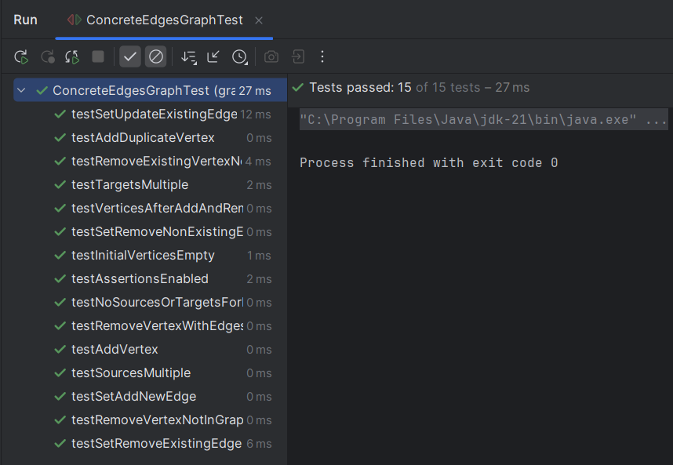

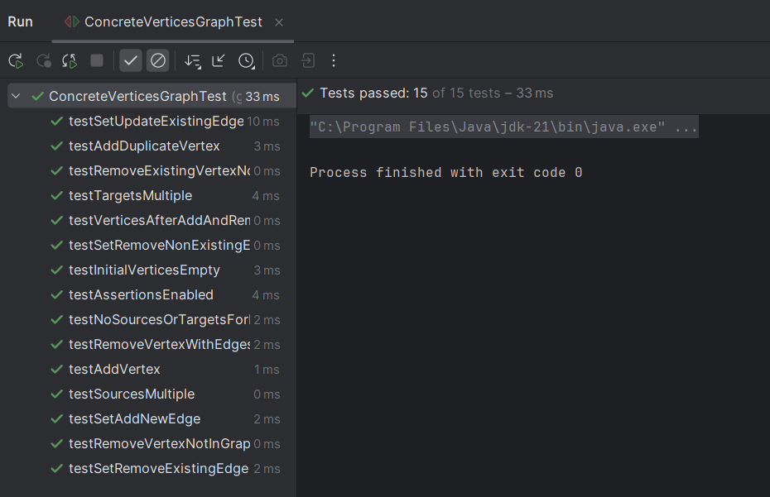

- Push Your Code on GitHub
- Add Git Link in Document.
- Make a complete report with all screen shots

Source Code: Zip your source code and upload one file (Including Git link) on LMS as well.
Solution

Deliverables
Compile a single word document containing Git link by filling in the solution part and submit this Word file on LMS. Also Upload your source code on LMS. In case of any problems with submissions on LMS, submit your Lab assignments by emailing it to aftab.farooq@seecs.edu.pk.

